**Introduction**

The species abundance distribution (SAD) is one of the very few ecological patterns whose consistency in shape makes it akin to an ecological law (Lawton 1999, McGill et al 2007). Across varied ecosystems and taxa, the species abundance distribution is nearly always dominated by a few very abundant species and a larger number of increasingly rare species, generating a distinctive hollow- or J-shaped curve (Fisher 1943). Tempted by this remarkably general pattern, community ecologists have used the species abundance distribution to test numerous theories designed to determine which biological processes are most important for structuring assemblages of species (McGill et al 2007). However, using the species abundance distribution to infer underlying processes has proven frustrating because there is so little variation in the shape of this distribution, even in response to experimental manipulations (Supp and Ernest 2014), and many theories produce similar predictions that perform comparably well when compared to observed distributions (McGill et al 2007).

Ecologists have generally focused on explaining the species abundance distribution as emerging from ecological processes, but accumulating evidence suggests that statistical constraints may be involved in generating the most striking feature of the species abundance distribution – the hollow curve. Mathematically speaking, we can think of an SAD as an unordered vector of S values that sum to N, where S and N are the total number of species and individuals in a community. If our implicit null expectation for such a distribution is that it be uniformly distribute, the hollow curve we see in nature is indeed surprising and begs for explanation. However, multiple efforts to characterize the most-likely random expectation for the SAD have converged to find that in general, an appropriate statistical baseline for the SAD is in fact *a hollow curve*. Analogous to the way a Gaussian distribution emerges in the limit of many samples around a population mean, power-law or logseries distributions emerge as statistical attractors for abundance distributions (Frank 2009, 2019). The Maximum Entropy Theory of Ecology (METE) uses methods derived from statistical mechanics to find the most-likely form for numerous ecological distributions, given sparse information about broad community properties and minimal assumptions regarding ecological mechanism (Harte et al 2008, Harte 2011). Even parameterized only with S and N, METE predicts a log-series SAD that is an excellent fit to empirical SADs (Harte et al 2011, White et al 2012). Finally, we can use combinatorics to explore the set of *possible* forms, or feasible set, for an SAD with a particular S and N. Hollow curves, similar to empirical SADs, dominate most feasible sets for biologically-relevant combinations of S and N (Locey and White 2013). Given minimal assumptions about biological process, and instead using S, N, and our understanding of the most-likely form of a vector with S elements that sum to N, we therefore have good reason to expect most SADs to be hollow curves.

If SADs are statistically inclined to be hollow curves before biology even enters the picture, it is no surprise that we have struggled to interpret the hollow curve in biological terms. It may be more informative to evaluate SADs not in terms of their absolute shape, but in terms of their shape *relative to what we would expect simply due to S, N, and the statistical constraint* (Frank 2009, Locey and White 2013). While the general hollow-curve may be a statistical artefact, it is still possible that biological processes push real SADs away from their most likely outcomes. This could result in relatively subtle, but meaningful, deviations between observed SADs and their statistical expectations (Locey and White 2013, Harte and Newman 2014). If we detect such deviations, we can evaluate theories in terms of how well they predict the *deviations,* which is to say, how much additional predictive power they give us beyond what is inherent to S and N (Harte and Newman 2014, Xiao et al 2016). If we cannot distinguish between observed species abundance distributions and their statistically-most-likely forms, there may be little information we can extract from the SAD alone – either because it does not contain appreciable signal of biological process, or because the range of highly-likely forms for the distribution obscures that signal.

Our capacity to detect deviations between observations and randomness could depend strongly on the distribution of statistically-likely outcomes, which in turn depends on the size of the system in terms of S and N. Generally, in the study of complex systems, predictions for the most-likely state of a system are most easily and confidently derived “in the limit” of aggregating over large numbers of components – for example, atoms of gas in a vessel (Frank 2009, Harte et al 2011). As the number of particles in the system becomes very large, the set of *possible* states of the system clusters tightly around a single highly-likely state, meaning any other outcome would be a true statistical surprise (Jaynes 1957). Unlike vessels of gas, ecological communities do notalways have effectively infinite subcomponents, and may have not have such narrowly-defined random expectations. This can interfere with our ability to detect deviations from randomness. If there is a narrowly-defined, overwhelmingly most-likely form for a particular SAD, even a relatively small departure from this outcome is highly unlikely to occur at random. However, if the probability distribution of possible forms for an SAD is relatively broad, even observations that are quite different from the *most* likely outcome are not necessarily highly unlikely. When this occurs, we cannot be sure if an observation that differs from the most-likely outcome, but falls within the realm of statistical possibility, is a result of random sampling or a reflection of nonrandom process. We expect this situation to be more common in smaller communities, but *a priori* we do not know the specific ranges of S and N for which it will be relevant.

We set out to establish if, and in what ways, we can detect consistent deviations between empirical SADs and their statistical constraints. If present, consistently *detectable* deviations would provide new leverage for interpreting SADs in biological terms. Such deviations likely betray non-random processes at work, and we may be able to use the deviations to evaluate theoretical predictions and make comparisons between empirical systems. The *absence* of detectable deviations would not necessarily be evidence of an overall lack of structural processes, but would mean that it is likely to be quite difficult to extract biological information from the SAD. Especially if such a lack of detectable deviations corresponds with small communities that have relatively vaguely-constrained SADs, we suspect it reflects the limits of our ability to make confident statistical distinctions in those contexts.

For [# communities] communities spanning X Y and Z taxa, we characterize the distribution of statistically-likely forms for the SAD based on the number of species and number of individuals. We then compare *observed* SADs to their corresponding statistical baselines and test 1) whether observed SADs are consistently unusual given their statistical expectations, and 2) whether our capacity to detect deviations seems to vary systematically over *S, N,* and corresponding variation in the narrowness of the statistical constraint.

**Methods**

*Datasets*

We use a compilation of datasets of community abundances for trees, birds, mammals, and miscellaneous other taxa that has been used in recent macroecological explorations of the feasible set (White et al 2012, Baldridge et al 2014). It includes data from trees in the Forest Inventory and Analysis and Gentry plots, birds in the North American Breeding Bird Survey, the Mammal Community Abundance Database, and a variety of less commonly sampled taxa in the Miscellaneous Abundance Database.

For datasets with observations from multiple years, we follow White et al (2012) and Baldridge et al (2014) and analyze only a single year of data. The Mammal Community Abundance Database and Miscellaneous Abundance Database include data collected over longer timescales that cannot be disaggregated, with an average temporal scale of X.

*the statistical constraint*

Following Locey and White (2013), we use combinatorics to characterize the statistical constraint on the SAD. For any given number of individuals *N*,there is a finite set of unique ways to partition those individuals into *S* species. The full set of *possible* SADs for a given S and N is the “feasible set”. A uniform sample of elements from the feasible set reflects the distribution of possible forms for an SAD, and – to the extent to which the elements of the feasible set converge towards one overall shape – illustrates both the shape of the most-likely form and the narrowness of the constraint. Uvalues of

Even with this algorithm, it is computationally intractable to sample the feasible set for very large communities. We therefore filtered our datasets to remove communities with more than X species or X individuals, or fewer than 2 species or X individuals. It is trivial to study the SAD for communities with only 1 individual for every species, so we also removed communities for which N = S.

The FIA database contains roughly 100,000 communities, of which 90,000 have fewer than 10 species and X individuals. Rather than analyze all of these small communities, we randomly selected 10,000 small communities to include in the analysis. In all, we analyzed X communities encompassing X taxa, with S and N ranging from 2 to X and X to X, respectively.

*Effects of S and N on the size and central tendency of the feasible set*

To illustrate how the narrowness of the statistical constraint varies S, N, and the size of the feasible set, we measured the self-similarity of elements of the feasible sets for combinations of S and N spanning the ranges represented in our data. For each S and N combination, we drew a maximum of 4000 unique samples from the feasible set. We then randomly drew a maximum of 4000 pairs of SADs from each set of samples and calculated four measures of similarity between each pair: a direct calculation of R2 common in macroecology [R2 formula] (Locey and White 2013; macroecotools; meteR), the coefficient of determination from a linear model fitting one sample to the other, the proportion of individuals allocated to different species, and an estimate of the K-L divergence. Each of these measures has unique imperfections in this context, but the four measures all arrive at qualitatively similar outcomes. We take the mean value of each of these measures as a rough indication of the narrowness of the statistical constraint for that combination of S and N.

*Comparing observed SADs to their feasible sets*

We compare the forms of observed SADs to their feasible sets by establishing a distribution of summary statistics for the SADs present in the feasible set and comparing the summary statistic values for the observed SADs to these distributions (after Locey and White 2013). We used skewness and Simpson’s evenness as our summary statistics, and calculated the percentile rank of the value for each observed SAD compared to the distribution of values obtained from its feasible set. Skewness can be calculated multiple ways, but using different formulas yields qualitatively identical results. It cannot be calculated for SADs with fewer than three species, and it is infinite in the special case where every species has the same number of individuals.

The range of values we observe for both statistics depends on S and N, so in order to synthesize across communities with different S and N we must focus on the percentile value, rather than on the raw values of the statistics. We calculated percentile rank as the percent of values in the distribution less than or equal to the observed value. Note that the precise meaning of this value differs subtly depending on whether the distribution of samples from the feasible set represents a true distribution of *samples* or an exhaustive account of all elements in the feasible set. If the samples are exhaustive, the percent of samples less than or equal to the observed value may be 100, but can never be 0 – even if the observed value is the lowest value possible, it is still less than or equal to itself. However, if sampling is not exhaustive, we may obtain a percentile value of 0 if the observed value is less than the lowest value we came across via sampling.

At random, we would expect the percentile values to be uniformly distributed from 0 to 100. If observed SADs are consistently more skewed or even than their feasible sets, the percentile values will be disproportionately concentrated towards the extremes. If, as we suspect, smaller communities have relatively vaguely-defined statistical constraints, we may not perceive consistent deviations from randomness in those communities. To show how the narrowness of the statistical constraint may inform our results from actual datasets, we repeated the self-similarity analysis (above) for every S and N actually represented in our database. We present results for percentile values aggregated over all datasets, and sub-set according to the size and self-similarity of the feasible set.

*Effects of rarefaction*

Whenever we survey the species present in a real system, we are likely miss some species – particular rare or cryptic ones. To test whether adding these presumably-present but unaccounted-for species affects our results, we ran our analyses on both raw data and on SADs adjusted via rarefaction. For each raw SAD, we took the mean number of estimated species from [] richness estimators, and added species to reach this mean estimated richness. We reasoned that species missed during sampling are likely to be rare, and added a single individual each for each added species. This allowed us to explore the consequences of rarefaction while making the smallest possible changes to S and N.

**Results**

*Effects of S and N on the narrowness of the statistical constraint*

Across the range of S and N we sampled, the number of elements in the feasible set increases rapidly with S, N, and the ratio of N:S (Fig 1). While most feasible sets are quite self-similar, self-similarity declines sharply for communities with fewer than [n] elements in the feasible set, or (approximately) fewer than S species or N individuals (Fig 2, Fig 3). This is consistent with our expectations drawn from statistical mechanics (Jaynes 1957, Harte et al 2011). For large communities with large, highly self-similar feasible sets, we have a very specific and narrowly-defined statistical constraint. We can be confident that even slight deviations from this baseline are very unlikely outcomes. However, we may not be able to make such distinctions for small communities with smaller and less self-similar feasible sets. For these feasible sets, even an outcome that is quite dissimilar to the *most* likely outcome is still within the realms of statistical possibility. Importantly, we see a decline in self-similarity for values of S and N that are common in ecology To the extent that low self-similarity limits our ability to detect deviations from the random baseline, we may stand to learn from SADs only for relatively large ecological communities.

*Observed SADs relative to their constraints*

Observed SADs are consistently, but not overwhelmingly, very skewed and uneven compared to their feasible sets. Overall, 6.8% of observed SADs are more skewed than 95% of their feasible set, and 14% are less even than 95% of their feasible sets. By chance we would expect only 5% of observed FS to fall in these ranges.

This result depends strongly on the size of the feasible set (Fig 7, Fig 9) and the self-similarity of the feasible set (Fig 6, Fig 8), which are tightly coupled. The distributions of percentile scores for empirical SADs with large, self-similar feasible sets are obviously non-uniform, but this pattern is less pronounced for smaller, less self-similar, feasible sets. For skewness, the non-uniformity disappears entirely for small feasible sets: for the 70% smallest feasible sets, only an average of 3% of observed SADs are more skewed than 95% of their feasible sets, but for the 30% largest feasible sets, 15% of observed SADs are similarly skewed. The overrepresentation of very low *evenness* scores is more consistent across feasible set sizes, but is also more pronounced for larger feasible sets. For the smaller 70% of feasible sets, 9% of SADs are lesseven than 5% of their feasible set. For the largest 30%, 25% of SADs are highly uneven (Table 1).

*Effect of rarefaction*

SADs corrected for rarefaction are almost always *more* unusual, if anything, compared to their feasible sets than the raw distributions. In nearly all communities, the rarefied percentile value for evenness is lower than for the raw distribution, and the percentile value for skewness is higher than the raw one (Fig 10, Fig 11). For evenness, this outcome is consistent across almost all feasible sets and does not vary with the size of the feasible set (Fig 12). Outcomes for skewness are more variable; some SADs do become *less* comparatively skewed when corrected for rarefaction. This is most pronounced for small feasible sets (Fig 13) and communities that are species-rich but have low average abundance (Fig 14). These communities are unusual in that all elements of their feasible sets must be quite uneven. Correcting for rarefaction, overall 10% of SADs are more skewed than 95% of their feasible sets (Fig 15), and 20% are less even than 95% of their feasible sets (Fig 16). High skewness values are overrepresented for the largest 70% of feasible sets – rather than only the largest 30% for uncorrected distributions – and low evenness values are overrepresented across all feasible set sizes (Table 2). This may be partially due to our decision to add new species as singleton species, because adding singletons to a distribution without changing the rest of its shape necessarily increases skewness and decreases evenness.

**Discussion**

Empirically observed SADs often deviate pronouncedly from their statistical constraints, but this is by no means a rule even for the largest communities. We do not find strong deviations for small communities, but we are hesitant to interpret this as a biologically-driven phenomenon. We think it more likely that the characteristics of the statistical constrainton those communities limit our capacity to detect any but the most extreme deviations.

more– but note that it is hardly uncommon for the observed SAD to fall well within our random expectation. This range of variation in *deviation* between observation and random expectation may provide new leverage for evaluating theory and drawing contrasts between communities. If a theory can correctly predict whether a community will or will not deviate, or better still the magnitude of the deviation, it is telling us considerably more than we would be able to infer from S and N alone. Similarly, we may be able to identify differences between communities that determine whether their SADs are detectably different from the constraint.

For a substantial proportion of relatively small communities, we do not detect any consistent deviation from randomness. It is technically possible that these small communities differ in some substantive way from large communities, and that small communities are effectively random while large ones are structured by strong nonrandom processes. However, we think it more likely that our failure to detect deviations for small communities is simply a reflection of the underlying characteristics of the statistical constraints on these communities. Generally, small systems are problematic for approaches inspired by statistical mechanics, as ours is here. The statistically most-likely state for these systems is relatively broadly defined, and this can make even nonrandom outcomes difficult to distinguish from outcomes that could reasonably emerge at random. These considerations seem to be relevant for a surprisingly large subset of ecological communities. Unless we can develop more sensitive methods for detecting deviations, or a lack thereof, for these small communities, we should expect to learn the most by focusing on SADs from relatively large communities.

The SAD is a case study that illustrates how important it is to consider statistical baselines when we interpret “patterns” in ecology and especially macroecology. Like all ecological distributions, the SAD emerges from a suite of biological *and statistical* processes. In this case, the statistical constraint on the SAD thwarts our intuition for what constitutes a surprising form for the distribution. Accounting for the statistical constraint reveals more subtle patterns of variation, which may yield much more insight into biology than we have so far managed to extract from the famous hollow curve.

It is relatively intuitive to demonstratethis phenomenon for the SAD, but the general principle may be equally important for other, less tractable, distributions. Because the SAD involves partitioning discrete values into distinct categories, we can characterize the constraint fairly simply via combinatorics. Defining and accounting for the statistical constraints on more complex, often continuous, distributions poses additional challenges and may necessitate borrowing tools from other disciplines. If the SAD is any indication, rising to those challenges and incorporating the statistical baseline into our analyses of other ecological “patterns” is both necessary and richly informative.

**Figures**

##### Figure 1: S0, N0, lognparts for range of S*N space



##### Figure 1.5: Datasets in S*N space



##### Figure 1.75: Nparts for datasets



##### Figure 1.875: Nparts by S, N, N/S



##### Figure 2: Self-similarity over S*N space



##### Figure 3: Self-similarity vs. nparts, N/S



##### Figure 3.5 Self similarity for datasets



##### Figure 4: Overall percentile scores for skewness



##### Figure 5: Overall percentile scores for evenness



##### Figure 6: Skewness broken out by ROV metrics

ROV metrics binned into quantiles. So each histogram accounts for 20% of communities. The “1” panel for mean_cd is the 20% of communities with the lowest cd scores, etc.

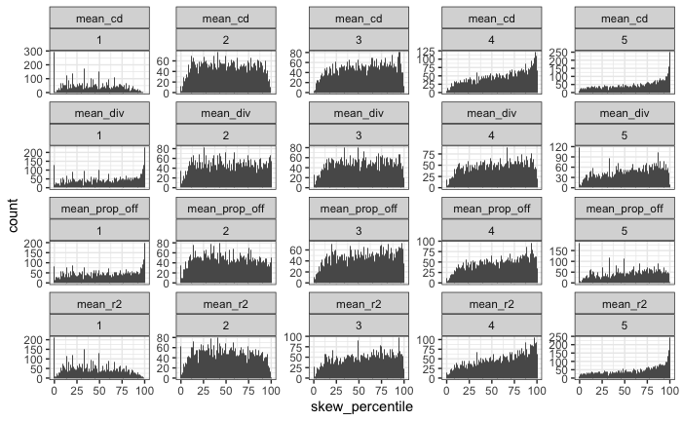

##### Figure 7: Skewness broken out by thresholded size of FS

Size of FS is broken into 10 bins by quantile. Facet labels are the maximum lognparts for that facet; so the 4.7 one is the 10% of communities with exp(3.5) – exp(4.7) parts.

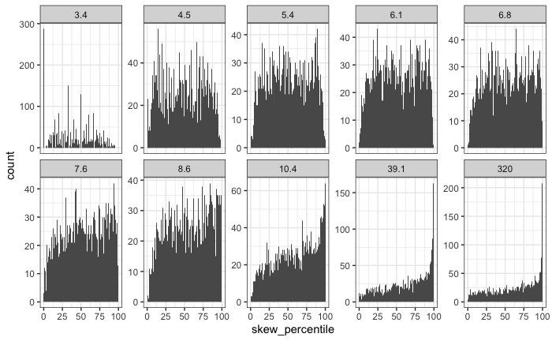

##### Figure 8: Simpson versus ROV

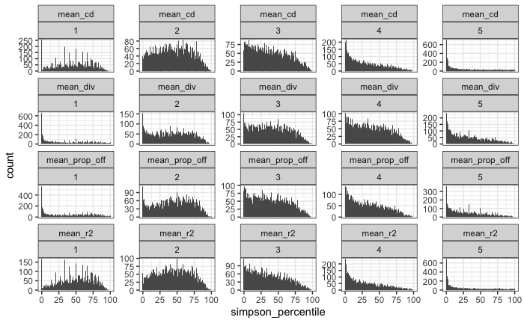

##### Figure 9: Simpson vs size of FS

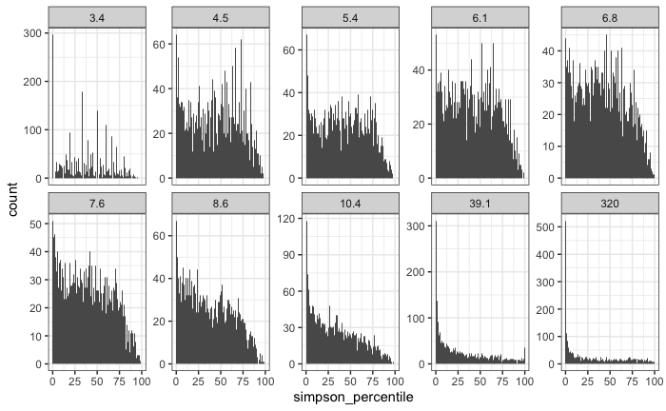

##### Figure 10: Skewness rarefaction change overall

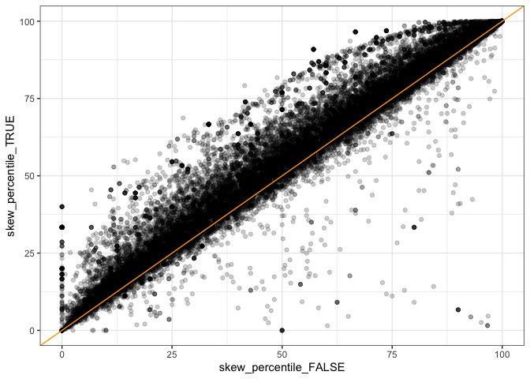

##### Figure 11: Simpson rarefaction change overall

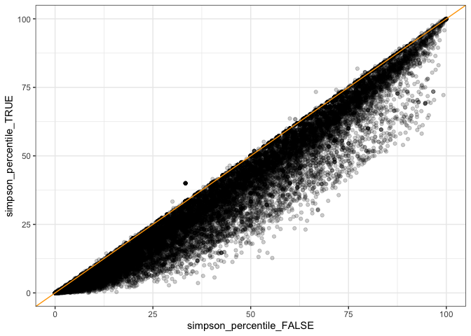

##### Figure 12: Simpson rarefaction by size of FS

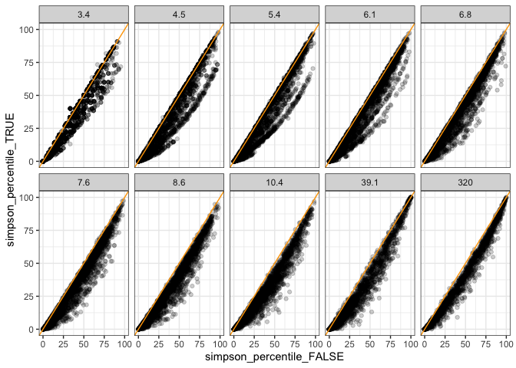

##### Figure 13: Skewness rarefaction change by size of FS

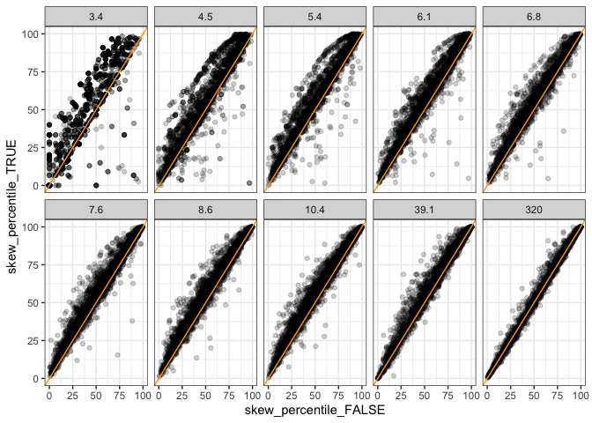

##### Figure 14: Skewness rarefaction change by S and N Green = rarefaction made the skewness percentile score go *down*

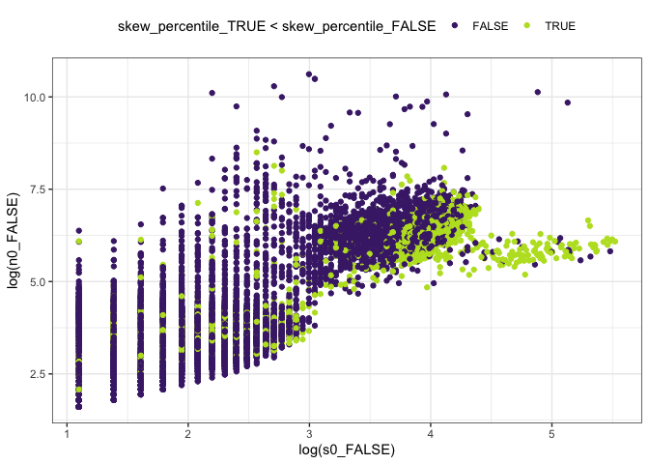

##### Figure 15: Rarefied skewness overall

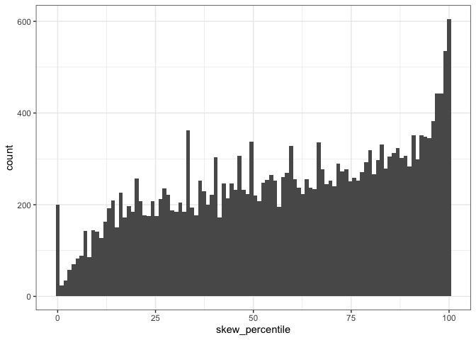

##### Figure 16: Rarefied evenness overall

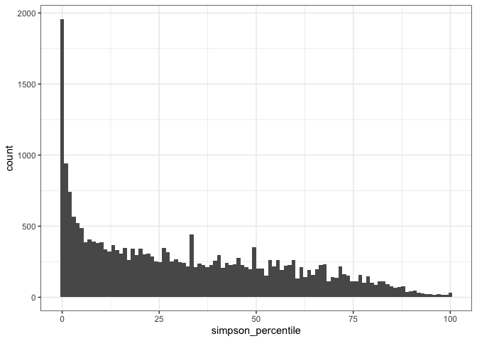

##### Table 1: Proportion of high/low %ile scores for raw vectors

Each qbin (**q**uantile **bin**) contains 1/10 of the communities, divided according to their number of parts. The bin cutoffs are the quantile values, and the bins are labeled according to their ceiling. So bin 3.4 is communities with up to exp(3.4) elements of the feasible set; bin 4.5 is communities with exp(3.4) – exp(4.5) elements, etc.

|  |  |  |  |  |
| --- | --- | --- | --- | --- |
| **qbinned_lognparts**  <ord> | **high_skew**  <dbl> | **Mean % high skew** | **low_simpson**  <dbl> | **Mean % low simpson** |
| 3.4 | 0.002145002 | 0.032 | 0.14671815 | 0.093 |
| 4.5 | 0.005966587 | 0.08711217 |
| 5.4 | 0.021093414 | 0.08824796 |
| 6.1 | 0.031839623 | 0.07311321 |
| 6.8 | 0.049509002 | 0.07692308 |
| 7.6 | 0.052173913 | 0.08737060 |
| 8.6 | 0.064155629 | 0.09478477 |
| 10.4 | 0.102647658 | 0.1505 | 0.14582485 | 0.251 |
| 39.1 | 0.173913043 | 0.27358491 |
| 320 | 0.175164474 | 0.33429276 |

##### Table 2: Proportion of high/low %ile scores with rarefaction

| **qbinned_lognparts**  <ord> | **high_skew**  <dbl> | **Mean % high skew** | **low_simpson**  <dbl> | **Mean % low simpson** |
| --- | --- | --- | --- | --- |
| 3.7 | 0.01030928 | 0.067 | 0.14144330 | 0.134 |
| 4.9 | 0.04293688 | 0.09832546 |
| 5.7 | 0.04755614 | 0.10171731 |
| 6.5 | 0.06222386 | 0.10456554 |
| 7.3 | 0.09323432 | 0.14975248 |
| 8.1 | 0.10764174 | 0.16269515 |
| 9.2 | 0.10412413 | 0.18089016 |
| 11.2 | 0.15765766 | 0.193 | 0.27027027 | 0.36 |
| 40.1 | 0.22764561 | 0.40401969 |
| 331.5 | 0.19491178 | 0.40664752 |